Research article
The title of this article
Author Name^{1,*}, Author Name² and Author Name³
¹ Department One, Institution One, City One, Country One
² Department Two, Institution Two, City Two, Country Two
² Department Three, Institution Three, City Three, Country Three

https://doi.org/10.53370/001c.xxxxx

○ Received dd/mm/yyyy ○ Accepted dd/mm/yyyy ○ Published dd/mm/yyyy
Abstract
Your abstract should give readers a summary of your article. It should concisely describe the contents of your article and include key terms. It should be informative, accessible and not only indicate the general scope of the article but also state the main results obtained and conclusions drawn. The abstract should be complete in itself; it should not contain undefined abbreviations and no table numbers, figure numbers, references or equations should refer. It should be suitable for direct inclusion in abstracting services and should not normally be more than 300 words. The text Times New Roman with size 10.

Keywords: Keyword 1; Keyword 2; Keyword 3; Keyword 4, Keyword 5; Keyword 6

- SECTION HEADING A
Authors should use any word processing software that is capable to make corrections on misspelled words and grammar structure according to Native English. Authors may get help by from word processor by making appeared the paragraph marks and other hidden formatting symbols. This manuscript template is prepared to assist authors preparing their articles to YJES.
Ensure that each new paragraph is clearly indicated. Present tables and figure legends in the text where they are related and cited. Number all pages consecutively; use 10 pt font size and standard fonts; Times New Roman. Indicate references by number(s) in square brackets in line with the text. The actual authors can be referred to, but the reference number(s) must always be given. Example: "..... as demonstrated [3, 6]. Barnaby and Jones [8] obtained a different result ...."
YJES accepts submissions in three styles that are defined as Research Papers, Short Communication, and Review paper. The requirements of paper are as listed below:
➢ Research Papers should not exceed 12 printed pages in two-column publishing format, including figures and tables.
➢ Short Communication should not exceed 2,000 words.
➢ Reviews should not exceed 20 printed pages in two-column publishing format, including figures and tables.
Authors are requested write equations using either any mathematical equation object inserted to word processor or using independent equation software. Symbols in your equation should be defined before the equation appears or immediately following. Use (1) for citing the equation in the text. Number equations consecutively with equation numbers in parentheses flush with the right margin, as in Eq. (1). Italicize Roman symbols for quantities and variables, but not Greek symbols. Use an dash (-) rather than a hyphen for a minus sign. Use parentheses to avoid ambiguities in denominators. Punctuate equations with commas or periods when they are part of a sentence, as in

C = a + b (1)

Section titles should be written in bold capital style while sub section titles are capital.The main text is written in font Times New Roman with size 10.
1.1 SUBSECTION A HEADING
Section titles should be written in bold capital style while sub section titles are capital.The main text is written in font Times New Roman with size 10. Sample text inserted for illustration. Replace with article text, including headings where appropriate. Figures and tables can be single- or double-column width as appropriate. During the production process they will be placed at the top or bottom of columns, after they are first cited in the text.
1.1.1 SUBSUBSECTION A HEADING
Section titles should be written in bold capital style while sub section titles are capital. The sub-sub section title is capital italic. The main text is written in font Times New Roman with size 10. Sample text inserted for illustration. Replace with article text, including headings where appropriate.
Figures and tables can be single- or double-column width as appropriate. During the production process they will be placed at the top or bottom of columns, after they are first cited in the text.
- SECTION HEADING B
Sample text inserted for illustration. Replace with article text, including headings where appropriate. Figures and tables can be single- or double-column width as appropriate. During the production process they will be placed at the top or bottom of columns, after they are first cited in the text. The property W was determined based on the previous work by [1] which can be found in (1) and (2). These equation should be written in a proper formatting e.g. Equation in MS Word.

W=mx+c (1)

$Z=\frac{P×v}{πr^{2}}$ (2)
Figures and tables can be single- or double-column width as appropriate. During the production process they will be placed at the top or bottom of columns, after they are first cited in the text. Properties of the materials used inthis work are listed in Table 1 below.

Table 1. Table caption style
Item | Property A | Property B
1 | 100 | 150
2 | 200 | 225
3 | 300 | 312.5
4 | 400 | 406.75
5 | 500 | 404

2.1 SUBSECTION B HEADING
Section titles should be written in bold capital style while sub section titles are capital.The main text is written in font Times New Roman with size 10. Sample text inserted for illustration. Replace with article text, including headings where appropriate.
Figures and tables can be single- or double-column width as appropriate. During the production process they will be placed at the top or bottom of columns, after they are first cited in the text.

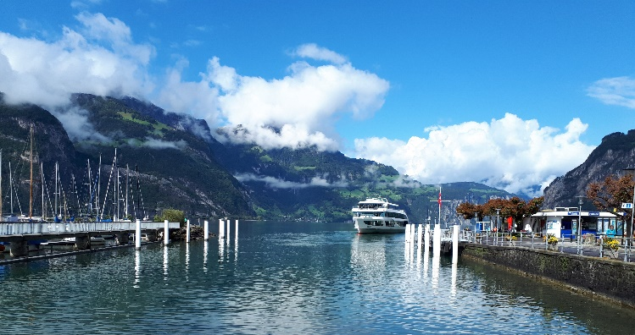
Figure 1: Figure caption style
2.1.1 SUBSUBSECTION B HEADING
Section titles should be written in bold capital style while sub section titles are capital. The sub-sub section title is capital italic. The main text is written in font Times New Roman with size 10. Sample text inserted for illustration. Replace with article text, including headings where appropriate.
Figures and tables can be single- or double-column width as appropriate. During the production process they will be placed at the top or bottom of columns, after they are first cited in the text.
- SECTION HEADING C
Sample text inserted for illustration. Replace with article text, including headings where appropriate. Figures and tables can be single- or double-column width as appropriate. During the production process they will be placed at the top or bottom of columns, after they are first cited in the text.text inserted for illustration. Replace with article text, including headings where appropriate.
Figures and tables can be single- or double-column width as appropriate. During the production process they will be placed at the top or bottom of columns, after they are first cited in the text.
3.1 SUBSECTION C HEADING
Section titles should be written in bold capital style while sub section titles are capital.The main text is written in font Times New Roman with size 10. Sample text inserted for illustration. Replace with article text, including headings where appropriate.
Figures and tables can be single- or double-column width as appropriate. During the production process they will be placed at the top or bottom of columns, after they are first cited in the text. consequat. Etiam eget dui. Aliquam erat volutpat. Sed at lorem in nunc porta tristique.
3.1.1 SUBSUBSECTION C HEADING
Section titles should be written in bold capital style while sub section titles are capital. The sub-sub section title is capital italic. The main text is written in font Times New Roman with size 10. Sample text inserted for illustration. Replace with article text, including headings where appropriate.
Figures and tables can be single- or double-column width as appropriate. During the production process they will be placed at the top or bottom of columns, after they are first cited in the text.
- CONCLUSION
The conclusion section should emphasize the main contribution of the article to literature. Authors may also explain why the work is important, what are the novelties or possible applications and extensions. Do not replicate the abstract or sentences given in main text as the conclusion.

Acknowledgements
Authors may acknowledge to any person, institution or department that supported to any part of study.

Abbreviation

NG Natural Gas
PP Polypropylene
IoT Internot of Things

REFERENCES
- Reference to a journal publication: Van der Geer, J., Hanraads, J.A.J., Lupton, R.A., 2010. The art of writing a scientific article. J. Sci. Commun. 163, 51–59. https://doi.org/10.1016/j.Sc.2010.00372.
- Reference to a journal publication with an article number: Van der Geer, J., Hanraads, J.A.J., Lupton, R.A., 2018. The art of writing a scientific article. Heliyon. 19, e00205. https://doi.org/10.1016/j.heliyon.2018.e00205.
- Reference to a book: Strunk Jr., W., White, E.B., 2000. The Elements of Style, fourth ed. Longman, New York.
- Reference to a chapter in an edited book:Mettam, G.R., Adams, L.B., 2009. How to prepare an electronic version of your article, in: Jones, B.S., Smith , R.Z. (Eds.), Introduction to the Electronic Age. E-Publishing Inc., New York, pp. 281–304.
- Reference to a conference paper: Gaba, V. Kumar, P. Nashine, and S. Bhowmick. (2012) "Combustion Modeling of Diesel Engine Using Bio-Diesel as Secondary Fuel." in International Conference on Mechanical and Robotics Engineering (ICMRE'2012) Phuket, Thailand, pp. 89-93.
- Reference to a website:Cancer Research UK, 1975. Cancer statistics reports for the UK. http://www.cancerresearchuk.org/aboutcancer/statistics/cancerstatsreport/ (accessed 13 March 2003).
- Reference to a dataset: [dataset] Oguro, M., Imahiro, S., Saito, S., Nakashizuka, T., 2015. Mortality data for Japanese oak wilt disease and surrounding forest compositions. Mendeley Data, v1. https://doi.org/10.17632/xwj98nb39r.1.
- Reference to a patent: Sattler ER, Myers JS, Haspel MJ. Continuously Variable Runner Length Manifold. US Patent 5950587. 1999.

